The Pandemic Pain is More Serious in Emerging Markets and Developing Countries: Causes and Remedies.
Institution affiliation
Student’s Name
Date of Submission

Executive Summary
This report discusses the impact of covid 19 on emerging markets and developing countries. After the Coronavirus was declared a global pandemic, it has drastically affected the world economy, and more so, EMDEs countries have significantly been hit by the pandemic. Most government-imposed measures such as lockdowns, quarantines, trade restrictions like cessation of movements which degraded the economic scale of the country and caused an economic crisis. Such measures resulted to a substantial decline in output and lowered the living standards of most of the people in EMDEs countries. The paper also elaborates on some of the areas affected as a result of covid 19 containment measures. These areas include; the money market, production, and manufacturing. Also, the report provides possible remedies that can be used to fight the pandemic as well as ensuring economic recovery after the pandemic. The remedies include; promoting equality, engaging in global coordination and cooperation, and reducing public debt.
The report is evident as it presents information on how EMDEs governments should react to contain the pandemic and enhance the public health system by helping workers, businesses, companies and firms to withstand the economic shock. The report also explains some of the schematic policy phases that can be applied during and after the pandemic. The policies include monetary and fiscal policies and how they should be restructured to be functional during the pandemic. As part of the remedy to reduce the pandemic's negative impacts on EMDEs, the paper presents some mitigating measures to sustain the economic activities by supporting households, essential services, and firms. Where necessary, figures and graphs have been appropriately used to explain the scenarios.

The Pandemic Pain is More Serious in Emerging Markets and Developing Countries: Causes and Remedies.
Introduction
The Coronavirus has been a global pandemic that has negatively affected the economy of countries across the world. Most of the effects have been felt by the emerging markets and developing economies in the sub-Saharan countries. However, some Eastern European emerging markets like Moldova, Poland, Romania, and Serbia have also been deeply hit by the pandemic. The impact has affected developing economies and some of the developed countries like the United Kingdom that experienced a sharp decline in its Gross Domestic Product (GDP). As a result, most of the countries have experienced increased unemployment, reduction in working hours, temporary layoffs, high death rates, especially to the men and the old, increased poverty, low savings, low investments, reduced revenues to the government, low population and discouragements in the job search that has led to the staggering economy. There are possibilities that these economies can be restructured, but still, both the indirect and direct financial costs are enormous. During this particular time, savings is one of the instruments used by people worldwide as part of financial security. State governments, central banks as well as commercial banks use the same formula to shape their spending.
At the onset of the pandemic, most predictions looked at developing economies as areas that record-high death rates. The assumption was that most of these developing economies have inadequate resources in the health sector like fewer hospital beds, inadequate medical equipment, and health workers to fight the diseases. Surprisingly, the death rates have been very high in developed economies like the United States and Europe than in Emerging Markets and Developing Economies (EMDEs). Some of the reasons why Latin America has been hit hard by the coronavirus include the inequality gap, existence of many informal sectors, large population in the cities, increasing rate of internal migration, and inadequate public health system. Additionally, Latin America has less experience in the inversion of deadly viruses when compared to Africa and East Asia, where people have experienced Ebola and severe acute respiratory syndrome (SARS). It is perceived that people from those regions have been cautious about the consequences of deadly viruses, and they have been taking respective measures like maintaining social distance to save their lives.
The Coronavirus has affected the financial markets and the world economy by interfering with businesses and organizational activities. It has negatively affected income as a result of low productivity, remote working, and premature deaths. Although it’s an impact that shakes the global economy, emerging markets and Developing Economies are greatly affected. Due to staggering economic activities, most of the EMDEs took loans to be used to fight the pandemic. Even before the pandemic onset, most EMDEs countries had debts, and others had few chances to undertake discretionary fiscal policies. This is an economic situation that can easily send EMDEs countries into a default state. The projection shows that in 2021, the EMDEs' budgetary deficits are likely to double to almost 10.5% of their GDP averagely than in 2019. Also, government debt is predicted to cover up to 63% of the total GDP, increasing by over 10% from 2019.
In terms of external debts, EMDEs have over $11 trillion in external debt and approximately $3.9 trillion in debt service. The pandemic has created a global health emergency plan, and, likely, the unconditional increase in debt can also create an international development emergency plan. This situation invites a high risk of insolvency that cannot be controlled by raising the alarm on corporate default risks. To reduce the dilemma of both international and internal debts of EMDEs countries, there must be a technique to write off their interest payments in the coming years. Alternatively, since these countries need extra support, International Monetary Fund (IMF) should also come in hand and expand these countries' credit lines.
The increase in public debt and pressure created by the coronavirus pandemic in emerging markets and developing countries have created a long-run crisis, especially in the health sector. After all, there are high chances that more focus is placed on coronavirus, therefore, underfunding other crucial health welfare programs. EMDEs countries have inadequate health resources, and there are also many other diseases that are not related to the pandemic, but they are killing more people. As a result, government attention is on the pandemic and channels almost all of its funds for the health system in treating covid 19, neglecting other diseases such as tuberculosis, malaria, and HIV/AIDS. In 2020, almost 40 million children were not vaccinated in Pakistan. In the long run, this is crucial because if cutting funds continues, even other welfare like free maternity will be highly affected.
In figure 1, we can see that government debts in EMDEs have dramatically increased due to fiscal stimulus packages. Even if the fiscal stimulus is eliminated, EMDEs country's fiscal condition is worse due to a steady decline in revenue from a staggering economy. The research done by consultancy Oxford Economics shows that if the situation continues the way it is, Mexico's government debt is likely to rise by over 11% of the GDP by 2021. On the other side, India is also expected to increase by 8.7 % (fig 1). Country's such as Thailand, Poland, Chile, and Brazil declared larger stimulus debt packages, and this means that they receive large debt gains in return. However, a higher rate of government borrowing means an impetus that stimulates private sector development that seeks extra financial support to cover internal costs during the pandemic. Higher borrowing costs will also come at the expense of business investment, which will weigh on productivity and longer-term economic growth.
Exchange rate market in EMDEs
Advanced economies provided policy support to EMDEs economy policymakers on ways of sustaining the economic blow. Most of the emerging markets' economies tightened their policies to prevent capital outflow to avoid inflation due to depreciation in the exchange rate. Still, as a result of the pandemic, they have adapted policy equivalent to developed economies. Most of the emerging market economies use reserve barriers, allowing adjustment to exchange rate (fig 2). In many cases, most countries inject liquidity to facilitate their market activities; for example, countries like Poland and Indonesia further eased some policies to support credit. However, EMDEs should be in a position of engaging in massive exportation to the rest of the world for it to restore their economic growth. They will, in turn, earn a reasonable foreign exchange that can be used to repay their international debts.
The Impact of Imposed measures by the Government
Government measures such as imposing lockdowns as a means of contending the spread of the virus have caused total disturbances in the supply chain due to the closure of factories. For instance, China is one of the EMDEs, and the restrictions imposed, such as lockdowns, greatly influenced the production and manufacturing sector. Most of the production activities were halted and industries closed their operations. Since there was no supply, the demand for industrial products reduces dramatically.
Another sector affected is the service industry like hospitality, transportation, and tourism, as they have experienced losses due to travel bans. Other policies such as self-isolation and quarantine led to a massive reduction in consumption level, thus reducing the demand for goods and services. This is because consumers were forced to change their spending habits due to low income and household. Also, most people fear the nature of this pandemic because it's unpredictable; therefore, they save more than spending.
The Role of External Demand Shocks under no Lockdown condition.
In this scenario, we look at the Turkish demand factor (Fig 3). A reduction in demand for foreign goods creates a total decline in the output of the domestic sector. The graph below shows three scenarios, and the first scenario expresses the demand shock in the global condition. For instance, if a reflection from the Turkish data presents a decline in automobiles by a certain percentage, then it means there is a global decline for demand in automobiles across the world and, more so, EMDEs. Also, (fig 3) shows the change in total output, exports, and imports during the pandemic for both scenarios. The total result is reduced by 19.8% in the first scenario. The exports declined by 23.4%; this was 5.5 more than the decline experienced in the imports, which was 17.9%. This situation is more consistent with EMDEs countries because most of them depend on importing intermediate goods. Therefore, demand plays a critical role in the total economic costs; if foreign demand reduces, then aggregate output also reduces.
Investment and capital formation in EMDEs
Investment and formation of capital in developing countries and emerging markets were declining even before the Coronavirus hit, and this was caused by the unstable or fluctuating prices of raw materials, poor infrastructure, especially the research and development institutions were lacking and lack of modern equipment and machines, very high costs of production and seasonal employment. For instance, in Pakistan, 14% of its Gross Domestic Product is expenditures on investment. Out of this percentage, 10% is for the private sector while the remaining 4% is for public investment. It is said that the two proportions have to be regular for the past half a decade. However, the Pakistan industrial sector, which is essential to investment, had been declining before the coronavirus pandemic because, from research, it is evident comparing the years 2017-2018 and 2019 it had grew by 4.9% in 2017-2018 while in 2019, it only grew by 1.4%. When the Coronavirus pandemic hit, this economy was highly affected in terms of investments. Very few industrial investments and other investments were made due to the increased uncertainties of the labor force and high costs of production with reduced sales. The private sector still was not getting adequate financing from banks before March 2020, meaning it was producing less, and this reduced production has led to a decline in the growth of Gross Domestic Product. So, with the coronavirus, the case worsened.
Pakistan's main investment and capital formation in the past five years is seen to come from China-Pakistan Economic Corridor (CPEC). It is estimated to be a $60 billion infrastructure-oriented bilateral stimulus program coordinated jointly by Pakistan and China as a fraction of the bigger One Belt One Road Infrastructure. Now with the foreign country lockdown, such coordination was disabled, leading to worsening of Emerging Markets and developing economies in terms of investments and capital formation.
Remedies
During this disquieting moment, EMDEs country's policymakers need to look for immediate response to contain health and the economic crisis. In the long run, responsible authorities will need to employ comprehensive programs to propel economic growth drivers. Policies that strengthen the health system and the available impetus that stimulate economic growth should be rebuilt both in the short and long term. These impetuses include; supporting private sectors and distributing funds directly to other businesses.
Schematic policy phases during and after the pandemic
Figure 4 below provides an overview of possible procedures that EMDEs countries' tax policies can support their economies through the pandemic. The suggestions are structured in a systematic layout based on tax policy and how the pandemic and various policy responses may be implemented. At first, the EMDEs and other advanced economies should observe containment and mitigations to stop the pandemic's outbreak. Currently, mitigation policies should be the priority to reduce the spread of the Covid-19. Mitigation measures and containments usually include the imposition of stringent conditions on social and economic activities. They include lockdowns, quarantines, and social distancing, which have a negative impact on the economic progress of a country. This is a temporary stage that depends on the medical care and health system's level together with support from the population response.
Policy Frameworks for mitigating Economic Impact of Covid 19
During the mitigation of this pandemic, EMDEs countries should focus on sustaining economic activities by supporting households, essential services, and firms. For instance, other advanced economies such as the US responded domestically to the pandemic by introducing government rescue packages and induced recession. Even though EMDEs countries lack enough funds to introduce colossal spending on public health and supporting hard-hit households, they should emulate what other developing economies do to save their people. However, EMDEs should use monetary, fiscal, and financial policies to support households' income, employment, and firm cash flows to reduce the pandemic's economic scars. However, these policies should be favorable and flexible because of the lockdown's unpredictable nature and slow recovery (Fig 5).
Monetary Policy
EMDEs countries should cut down their policy rates and provide liquidity to solvent banks. In this case, I have used analysis of the Bank of Korea (BOK) (Fig 6). After the declaration of the pandemic, the Korean government introduced several measures that offer monetary support. BOK reduced interest rates from 1.25% to almost 0.5%. It also eliminated limits on funds and increased the number of OMO participants to add other non-bank financial institutions. The BOK reduced the collateral requirement for net settlements in the payment system to easy purchases of treasury bonds. Like what the BOK did, the EMDEs should also provide support by the lending facility and lower their interest rates. Other monetary policies that should be put in place by the EMDEs include; financial stability plan that focuses on expanding financial support to firms and companies. Another technique is facilitating purchases of financial bonds and corporate bonds and promoting the issuance of corporate bonds through collateralized bond terms. Additionally, they should use stock finance loans and providing support to short-term money markets.
Response to Fiscal policy
EMDEs countries should use an approach of the labor market and provide corporate support to protect worker's income and businesses during the pandemic. They should come up with effective supplementary budgets that cater for “disease prevention and treatment, loans and guarantees for business affected, support for households affected, and support for local economies affected.” Additional relief packages can also be used to easy revenues to support companies, creating more employment opportunities and social safety. Tax evasion is an integral approach to respond to fiscal policies. EMDEs should lay down a formula progressive tax to achieve equity in the tax pay rate. People receiving high incomes should be taxed according to their income, while those earning low should be taxed low. Taxes being the primary source of government revenue would help in case of such a pandemic. The developing countries should make sure there are no tax evaders, and this tax is used in the right way. This would have helped lessen the burden of the pandemic on these countries and their emerging markets. The business people also would be relieved of the tax burden they are facing.
EMDEs should respond to tax waive as a form of maintaining social security. Most common waives should focus on small businesses, particularly on property taxes and presumptive taxes. Most EMDEs countries should waive specific levies on airlines and tourism sectors because the pandemic hard hits them. Other sectors such as transport and manufacturing sectors should also be waived from import taxes. Tax waives have already been implemented in some EMDEs countries like Cambodia, Kazakstan, and Uzbekistan. EMDEs countries should implement measures that support investment and consumption. For example, countries such as Moldova and Kazakhstan lowered their income tax (PIT) and corporate income tax rate at low. They should also reduce standard VAT rates to create room for people to save and invest.
Promoting equality
Social, political, economic, and health inequalities were the prevailing narrative globally even before the coronavirus pandemic's emergence. The pandemic has extended these inequalities, including access to health care. The pandemic infections and deaths affected not proportionately the racial minorities confining Black, Hispanic, and Native American individuals. The people who were so much exposed to the SARS-COV-2 infection were the low-paid workers like the truck drivers, grocery store workers, and the meatpacking plants. Many white-collar professionals worked remotely with secure incomes, but at the same time, the US workers who are paid low incomes lost their jobs. The US rate of unemployment rose from 3.8% in February to 13% in May 2020.
Similarly, the country's population is affected in case of infectious disease. Still, the coronavirus pandemic showed that the people earning low incomes, the less educated, and those who are racial minorities are not proportionately affected. Surprisingly, the Black Lives Matter protests corresponded with the pandemic. Anger is being expressed everywhere by the population as they endure social, health, and economic injustices.
Engaging in Global coordination and cooperation
EMDEs countries should also engage in global coordination and cooperation to help them fight the spread of the coronavirus and emulate the economic formulas that help in alleviating the economic damages. These include seeking international support that can provide a positive approach that can be used to achieve public health goals and a substantial economic rapture. Like what happened in the previous debt crises, the international community should request private sectors to cooperate with the IMF and advanced economies countries. This will involve rescue packages connected with the IMF to take steps so that foreign exchange rates can be freed up on new public loans to debtor countries. "In the currency crises of the 1990s, this was known as “private sector involvement.” Similarly, in the 1982 international debt crisis, rich-country banks were “bailed in” to the rescue effort, rather than being “bailed out.” Where debt restructuring is necessary, private creditors should do their share."
By engaging in global coordination and cooperation, EMDEs countries will be able to use the three approaches including the multilateral approach where they will participate in intergovernmental organizations and engage in negotiable agreements (Fig 7). Through the bilateral approach, EMDEs will have mutual recognition through partnership with other countries.
Reducing Public debt
Reducing public debt, especially by the EMDEs government, would reduce the cost of living during the pandemic. When the government borrows from IMF and advanced economies, they increase liabilities to the economy, especially in EMDEs. Public debt causes a tax increase, high cost of living, and reduced savings and investments as almost all the income are consumed. Increasing public debts affects not only the citizens but also the emerging markets because it results in a decrease in the level of consumption due to the high prices of commodities. This leads to a market failure since the demand and supply mechanism has been affected.
From fig 8 above, even before the emergence of the pandemic, EMDEs had accumulated substantial public debts. Since 2010, EMDEs total debt increased by 60% of the GDP, recording a historic peak of more than 170% of GDP in 2019. Governments should be on the look to find possible solutions for the current high borrowing as a source of finance to support in fighting the pandemic. EMDEs countries might decide to restructure their budget to provide short-term debt relief, but it can be messy in the future economic scale. Developed countries and organizations should support EMDEs financially to recover their economic growth and advise them on appropriate debt measures.
Conclusion
The Emerging Markets Developing Economies have felt the coronavirus pain more greatly than the developed countries, as explained above. There are still opportunities to improve the crisis by reimagining privatization regulation, social protection, ensuring National reconciliation, equity, and making the environment sustainable. Alternatively, there is a great need to tighten the health system of the EMDEs and implement the remedies to support sustainable growth and development once the pandemic abates.

Work Cited
Akpan, I. J., Udoh, E. A. P., & Adebisi, B. (2020). Small business awareness and adoption of state-of-the-art technologies in emerging and developing markets, and lessons from the COVID-19 pandemic. Journal of Small Business & Entrepreneurship, 1-18.
Barua, S. (2020). Understanding Coronanomics: The economic implications of the coronavirus (COVID-19) pandemic.
Çakmaklı, Cem, et al. COVID-19 and emerging markets: an epidemiological model with international production networks and capital flows. National Bureau of Economic Research, 2020.
Contini, C., Di Nuzzo, M., Barp, N., Bonazza, A., De Giorgio, R., Tognon, M., & Rubino, S. (2020). The novel zoonotic COVID-19 pandemic: An expected global health concern. The Journal of Infection in Developing Countries, 14(03), 254-264.
Frankel, J. "The Pandemic Pain of Emerging Markets." Project Syndicate (2020).
Loayza, N. V., & Pennings, S. (2020). Macroeconomic policy in the time of COVID-19: A primer for developing countries.
Manley C. (2020). The consequences of COVID-19 on developing and emerging economies. Journal of International economics. Retrieved from: https://blog.realinstitutoelcano.org/en/the-consequences-of-covid-19-on-developing-and-emerging-economies/
Maria Nicola, Zaid Alsafi, Catrin Sohrabi, Ahmed Kerwan, Ahmed Al-Jabir, Christos Iosifidis, Maliha Agha, and Riaz Aghaf. “The socio-economic implications of the coronavirus pandemic (COVID-19): A review.” International journal of surgery (London, England) vol. 78 (2020): 185-193. doi:10.1016/j.ijsu.2020.04.018.
Martin Mühleisen et al. COVID-19 Response in Emerging Market Economies: Conventional Policies and Beyond. IMF. 2020. Retrieved from: https://blogs.imf.org/2020/08/06/covid-19-response-in-emerging-market-economies-conventional-policies-and-beyond/
Mofijur, M., Fattah, I. R., Alam, M. A., Islam, A. S., Ong, H. C., Rahman, S. A., ... & Mahlia, T. M. I. (2020). Impact of COVID-19 on the social, economic, environmental and energy domains: Lessons learnt from a global pandemic. Sustainable production and consumption.
Reinhart, C., & Reinhart, V. (2020). The pandemic depression: The global economy will never be the same. Foreign Aff., 99, 84.
Sanjeev Gupta and Lian Hong “The COVID-19 Crisis and Fiscal Reform in Low Income Countries” Centre for Global Development (CGD), June 1, 2020 https://www.cgdev.org/publication/covid-19-crisis-and-fiscal-reform-low-income-countries

Appendices
Figure 1
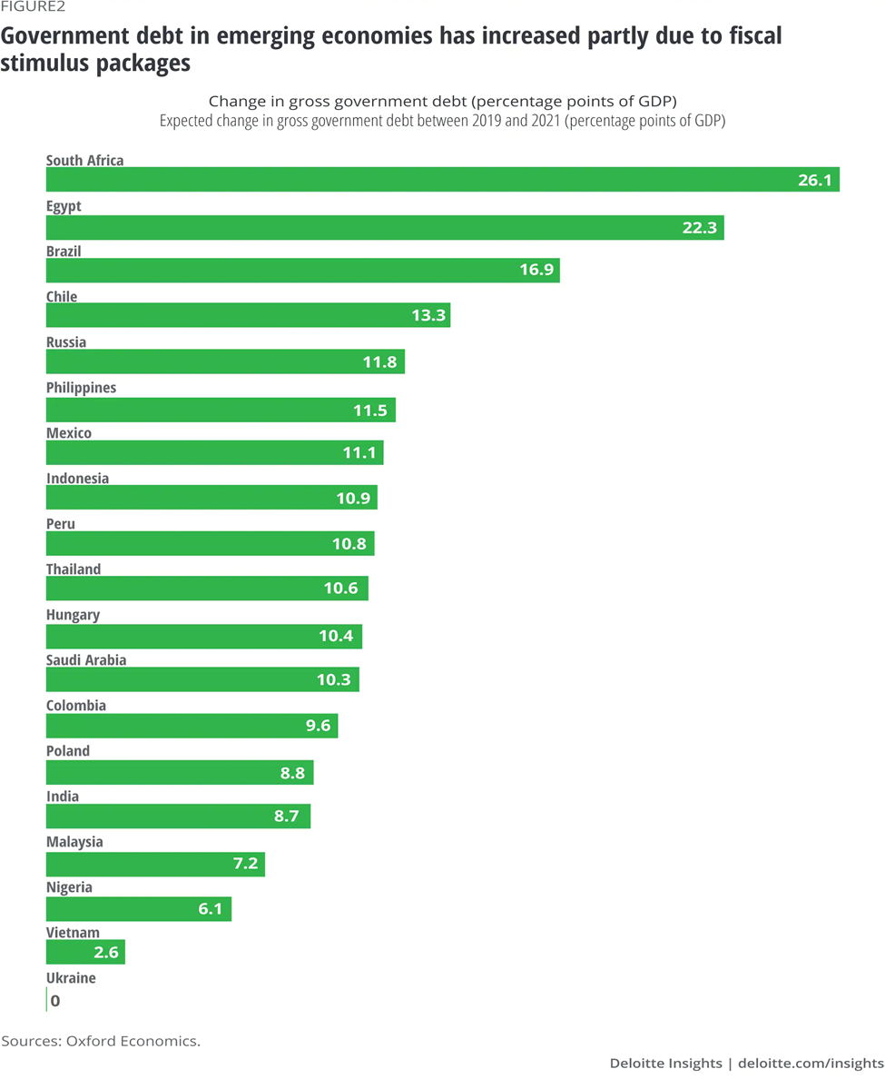
Figure 2
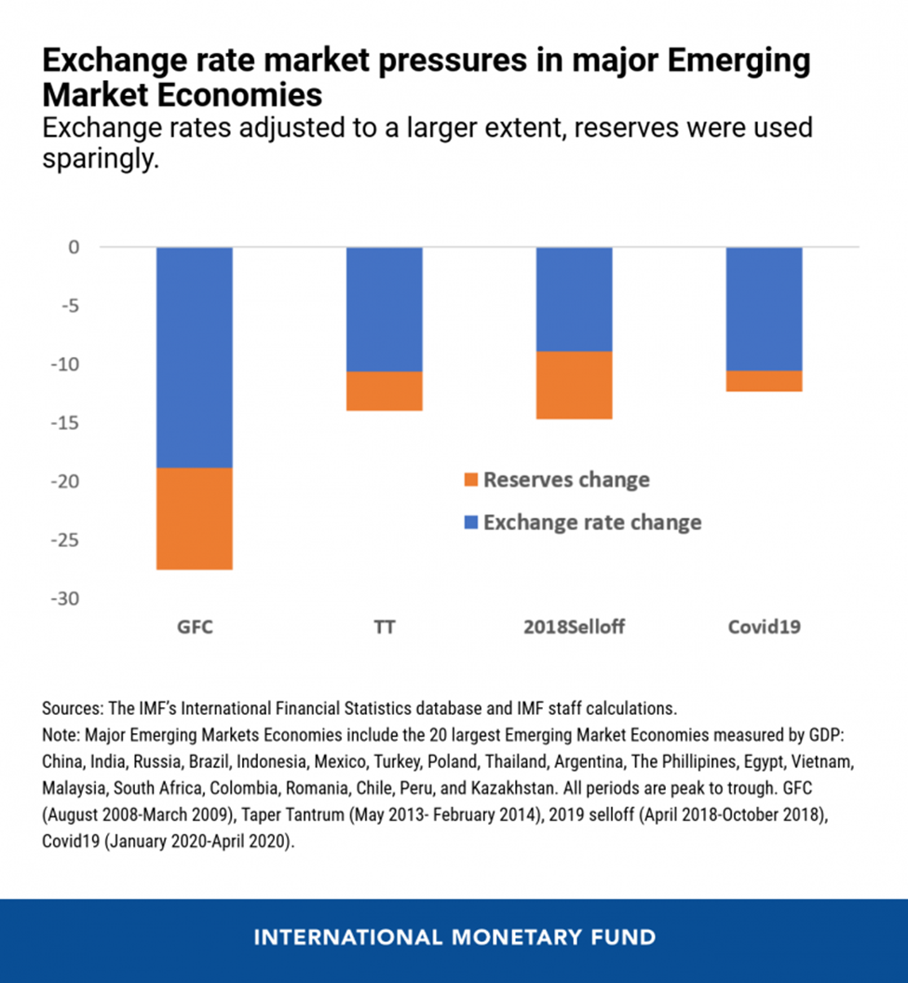

Figure 3
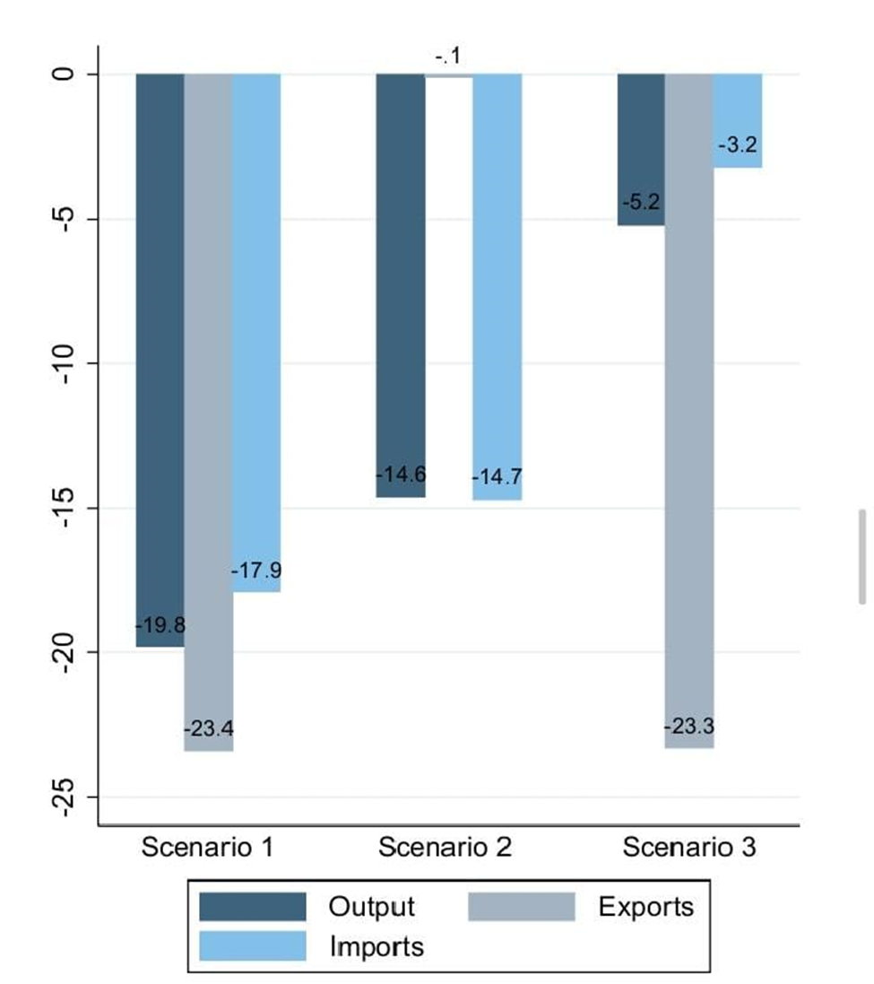
Figure 4
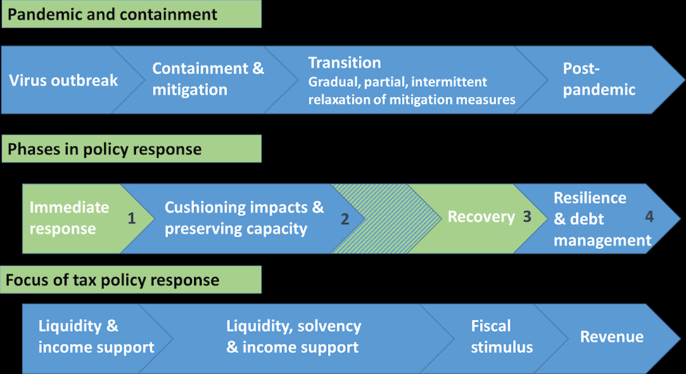
Figure 5
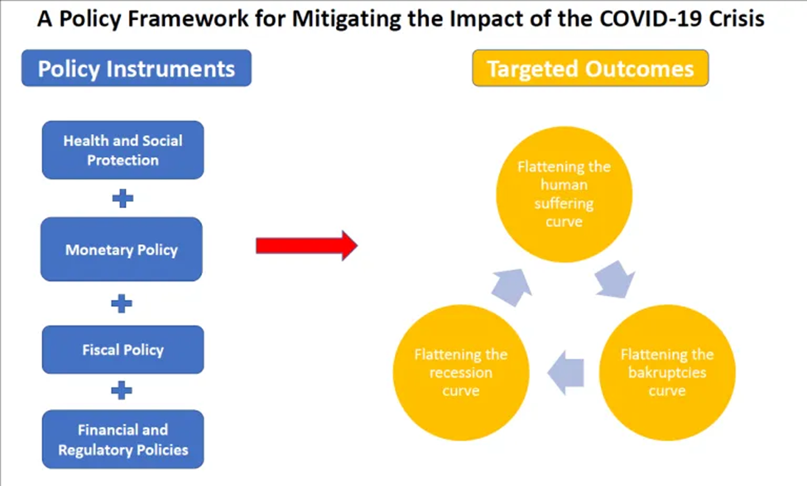
Figure 6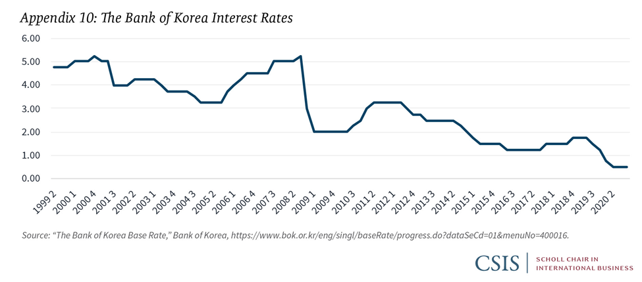
Figure 7
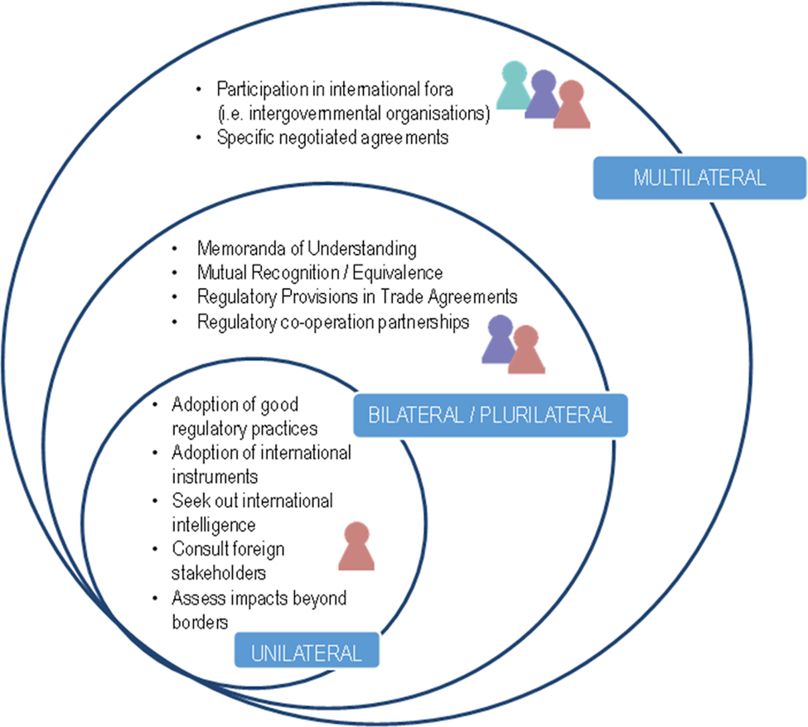
Figure 8
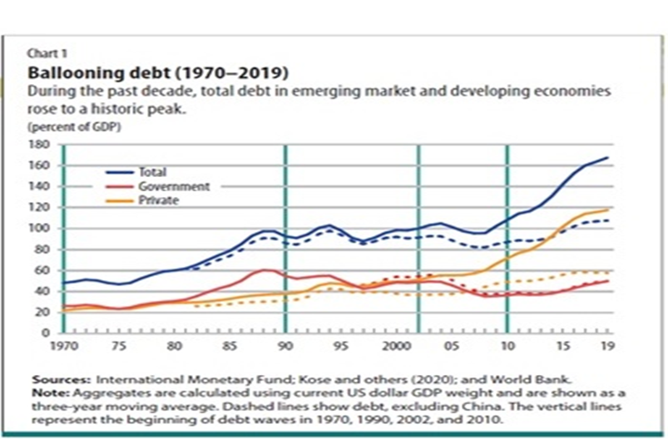

Frankel, J. "The Pandemic Pain of Emerging Markets." Project Syndicate (2020).
Maria Nicola, Zaid Alsafi, Catrin Sohrabi, Ahmed Kerwan, Ahmed Al-Jabir, Christos Iosifidis, Maliha Agha, and Riaz Aghaf. “The socio-economic implications of the coronavirus pandemic (COVID-19): A review.” International journal of surgery (London, England) vol. 78 (2020): 185-193.
Contini, C., Di Nuzzo, M., Barp, N., Bonazza, A., De Giorgio, R., Tognon, M., & Rubino, S. (2020). The novel zoonotic COVID-19 pandemic: An expected global health concern. The Journal of Infection in Developing Countries, 14(03), 254-264.
Martin Mühleisen et al. COVID-19 Response in Emerging Market Economies: Conventional Policies and Beyond. IMF. 2020.
Maria Nicola, Zaid Alsafi, Catrin Sohrabi, Ahmed Kerwan, Ahmed Al-Jabir, Christos Iosifidis, Maliha Agha, and Riaz Aghaf. “The socio-economic implications of the coronavirus pandemic (COVID-19): A review.” International journal of surgery (London, England) vol. 78 (2020): 185-193.
Barua, S. (2020). Understanding Coronanomics: The economic implications of the coronavirus (COVID-19) pandemic.
Frankel, J. "The Pandemic Pain of Emerging Markets." Project Syndicate (2020).
Çakmaklı, Cem, et al. COVID-19 and emerging markets: an epidemiological model with international production networks and capital flows. National Bureau of Economic Research, 2020.
Loayza, N. V., & Pennings, S. (2020). Macroeconomic policy in the time of COVID-19: A primer for developing countries.
Reinhart, C., & Reinhart, V. (2020). The pandemic depression: The global economy will never be the same. Foreign Aff., 99, 84.
Frankel, J. "The Pandemic Pain of Emerging Markets." Project Syndicate (2020).
Martin Mühleisen et al. COVID-19 Response in Emerging Market Economies: Conventional Policies and Beyond. IMF. 2020
Sanjeev Gupta and Lian Hong “The COVID-19 Crisis and Fiscal Reform in Low Income Countries” Centre for Global Development (CGD), June 1, 2020.
Çakmaklı, Cem, et al. COVID-19 and emerging markets: an epidemiological model with international production networks and capital flows. National Bureau of Economic Research, 2020.
Sanjeev Gupta and Lian Hong “The COVID-19 Crisis and Fiscal Reform in Low Income Countries” Centre for Global Development (CGD), June 1, 2020
Reinhart, C., & Reinhart, V. (2020). The pandemic depression: The global economy will never be the same. Foreign Aff., 99, 84.
Barua, S. (2020). Understanding Coronanomics: The economic implications of the coronavirus (COVID-19) pandemic.

